Lahore Garrison University
DHA Phase 6 Lahore



Student Name | Muneeb Ur Rehman
Student Roll No | Fa-2023-BSCS-490
Section | D
Subject | Web Technology
Instructor Name | Sir Muhammad Yousaf

Lab Task No. 09

Lab 9: DOM Manipulation — To-Do List

Objectives
- Create a dynamic to‑do list using DOM APIs: add/remove items, mark complete, persist to localStorage.
- Practice DOM manipulation, event handling, and saving data.

Tools/Tech
• VS Code
• Live Server
• localStorage
• JavaScript DOM API

Tasks/Steps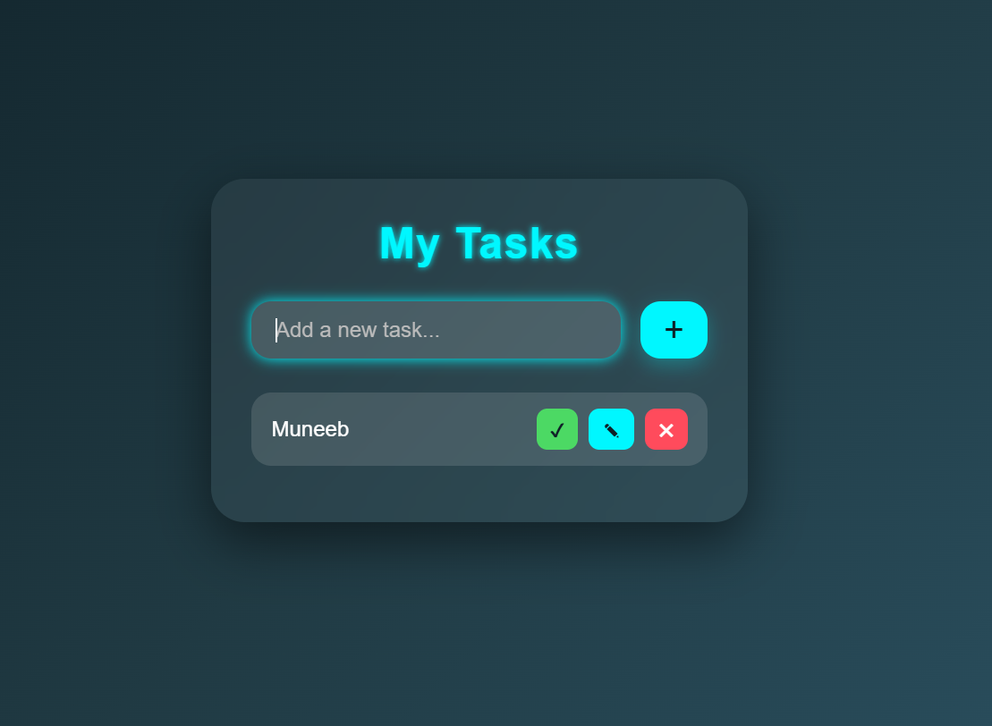
- Implement add, edit, delete, and toggle complete features.
- Persist list state in localStorage and load on page start.
- Enhance UI with CSS and allow Enter key to add tasks.

Deliverables
- To‑do list web app hosted in repo.
- README describing features.
# To-Do List App (Lab 9)

## Features
- Add new tasks
- Edit tasks
- Delete tasks
- Mark tasks as completed
- Save tasks using local Storage
- Loads tasks automatically on refresh
- Stylish UI and Enter key support
## How to Run
1. Open the project in VS Code
2. Start Live Server
3. Use input box to add tasks
4. Click a task to mark complete
5. Use delete/edit buttons to update tasks

Demo
- Working demo video/GIF.
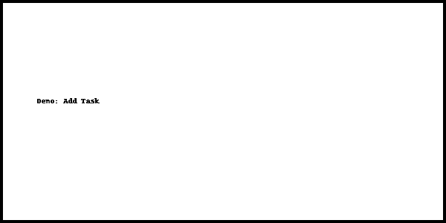

Conclusion:

In this lab, we successfully created an interactive to-do list using JavaScript DOM manipulation. We learned how to dynamically add, edit, delete, and mark tasks as complete, as well as how to store and retrieve data using local Storage so tasks stay saved even after refreshing the page. This lab improved our understanding of DOM APIs, event handling, and building real-time user interfaces.

RUBRICS:

Performance |  |  | Lab Report
Description | Total Marks | Marks Obtained | Description | Total Marks | Marks  Obtained
Ability to Conduct practical | 5 |  | Structure | 5
Data Analysis & Interpretation | 5 |  | Efficiency | 5
Total Marks obtained |  |  | Total Marks Obtained

Instructor Signature

